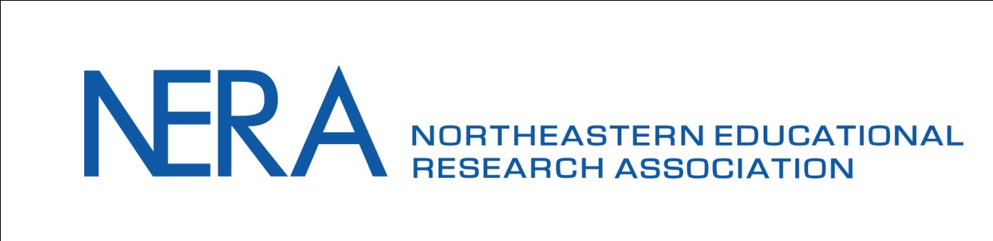

COMMUNICATION REQUEST FORM
Directions: Please complete all fields and submit as a Word document to the appropriate Coordinator listed below with a copy sent to Monica Erbacher Smith, NERA Communications Committee Chair (MonicaKErbacher@gmail.com):
E-mail: Duy Pham (dpham@umass.edu)
Social Media: Chastity Williams-Lasley (drclasley@gmail.com)
Website: Bozhidar Bashkov (bo.bashkov@gmail.com)
If requesting an email, to which email list should it be sent?
- Members
- Full-time students
- Prospective members
- Everyone
Rather than emailing attachments, we recommend you request your documents be posted to the NERA website. We can then simply email the link. In the past, spam filters have blocked our emails that included attachments.

Here are a few guidelines for approved NERA channels of communication:
- Official NERA news – email, website, and social media are appropriate
- Conference news – email, website, and social media are appropriate
- NERA Researcher – email, website, and social media are appropriate
- Job postings – social media and/or the NERA message board are appropriate (official NERA email not appropriate)
- Conferences – social media and/or the NERA message board are appropriate (official NERA email not appropriate)

Request Made By: <Please enter your name here>
NERA Position: <Choose from Committee Chair, Appointee, Board Member>
Type of Request Submission: <Choose from E-Mail, Social Media, and Website Post>
Date of Request Submission: <Please enter today’s date here>
Requested Date for E-mail/Post to be Sent/Posted: <Please enter target date here>
Originating E-mail Address: <Please enter a valid e-mail address here>
(E-mail of Individual Making the Request)
Reply E-mail Address: <Please enter a valid e-mail address here>
(Contact for E-mail/Post)
Subject Line: <Please enter your subject here>

<ENTER YOUR TEXT HERE>

Approved by: Approval Date:
Expected Release Date:

